**Smart Automation Management System and Data Analytics with   
AI-Enabled Demand Forecasting for Metro 7**

**A Thesis**

**Presented to the Faculty of the College of Computer Studies**

**AMA UNIVERSITY**

Maximina St. Villa Arca Subdivision,  
Project 8, Quezon City

In Partial Fulfillment of the Requirements for the

Degree in Bachelor of Science in Information Technology (BSIT)

By

**Eryck Paul S. del Fonso**

**Micheal Lance Kester Li**

**Michael Angelo E. Lim**

2022

**APPROVAL SHEET**

This Thesis entitled, **“Smart Automation Management System and Data Analytics with AI-Enabled Demand Forecasting for Metro 7”**, prepared and submitted by ERYCK PAUL S. DEL FONSO, MICHEAL LANCE KESTER LI, MICHAEL ANGELO E. LIM in partial fulfillment of the course requirements for the degree of Bachelor of Science in Industrial Engineering, has been examined and recommended for acceptance and approval for Oral Examination.

**DR. MAKSUDA SULTANA**

Adviser

Approved by the Committee of Oral Examination on April 25, 2023 with a grade of

**PROF. LUNIE MAY BANGSARA**

Member

**PROF. EMMANUEL TRINIDAD**

Member

**ENGR. JEFFREY LEONEN**

Chairman

Accepted as partial fulfillment of the course requirements for the degree in Bachelor of Science in Information Technology

**Dr. Maksuda Sultana**

Dean, College of Computer Studies

Date: April 25, 2023

**ACKNOWLEDGEMENT**

First of all, I would like to acknowledge and give praise and thank to our Lord who gave me this life and guided me in my journey to made this thesis possible. He gave me the needed strength and encouragement to surpass all the obstacles and challenging moments I faced in finishing my thesis. I will forever be grateful of his immense love of me. I am also truly grateful for my very patient and understanding mentors who helped me complete this study with accuracy and proficiency.

I would also like to thank my wonderful family and friends for their endless support and encouragement that powered me through the stressful days and tough nights that I endured to finish my thesis. I would like to thank everyone and even strangers who brought smile to me during these times, it alleviated the stress I’m feeling and helped me a lot.

To the Lord our God, to my family and friends, my adviser and everyone involved, you all are the reasons why I successfully finished this study. Thank you very much.

**ABSTRACT**

Our children are very dear to us. Thus, they should be given the utmost importance. Filipino parents as a whole only want the best for them for they are not only a great source of joy but also, they will be vital for how our country is going to be in the future. Therefore, everyone only wants the best product for their children. Products that can be considered as ergonomic is something that is growing in popularity and rightfully needed nowadays because they are highly beneficial to the health and wellbeing of the user. At the same time, multipurpose furniture is also popular and favored by the buyers because of their convenience. An ergonomic and multifunctional furniture has advantages compared to the usual furniture because it has more characteristics and features that is beneficial to the buyers and users. The ergonomic design of the furniture will help in mitigating any health issues of the children using it and can help in lessening the chance to develop any health issues in the future like musculoskeletal disorders and chronic pains. The design of the ergonomic furniture will also help the children using it to be in a relaxed position and feel comfortable providing a more conducive and effective learning environment.

**Table of Contents**

**LIST OF TABLES**

Table 3.1: Concept scoring matrix …………………………………………………………... 31

Table 3.2: List of materials used for the prototype…………………………………… 35

Table 3.3: Bill of materials.……………………………………………………………….38

Table 3.4: Criteria for product evaluation……………………………………………… 40

Table 3.5: The Likert scale ………………………………………………………………48

**LIST OF FIGURES**

Figure 1.1 Conceptual Framework of the Study……………………………………… 1

Figure 3.1 Concept 1 Hand Sketch………………..…………………………………… 27

Figure 3.2 Concept 1 Hand Sketch………………..…………………………………… 28

Figure 3.3 Concept 1 Hand Sketch………………..…………………………………… 29

# **CHAPTER I THE PROBLEM AND ITS BACKGROUND**

### **Introduction**

In modern times the integration of information technology has become a crucial part of the operations of business industries. The impact of Information Technology brought ease in business processes or operations such as marketing and inventory management by digitizing data. Inventory Management System (IMS) involves the supervision of stocks and the flow of the market to the warehouse and customers through a Point of Sales System (POS).

The Inventory Management System is an essential tool for businesses as it maintains comprehensive records of goods. However, most SMEs in the Philippines still prefer the traditional methods by relying on pen and paper to recording each data manually, which requires cumbersome and repetitive tasks. These methods are prone to inaccuracies and misinterpretation, posing risk to business operations. It also risks the misinterpreting of gathered data as business and marketing teams are often biased, leading to inaccurate forecasts even with properly segregated data. In these modern times, computers give automation to record all the process of data gathering, reducing the risks mentioned above.

Poor Inventory Management can lead to profit losses due to overstocking and understocking of goods and perishables. There are several factors that affect a company’s decision-making pertaining to inventory management and control, making it a challenging task for inventory managers. With fully developed tools and AI models like ARIMA concrete data-based decision making can be produced eliminating loss of revenue due to human error and biases.

For a small-end medium enterprise like Metro 7 Resto Bar, it is important to give utmost customer satisfaction for high customer retention, enabling SMEs to accurately meet customer demands, an introduction of an AI Enabled inventory and POS system will greatly reduce the risk from overstocking and understocking resources, it will also give the SME to adapt to market changes leading to an increased sale and having a competitive edge over other SMEs. A study noted that Philippines is still in its early stages, with only 14.9 percent of business use AI technology. Making Metro 7 Resto Bar to be the Pioneer of an AI enabled Inventory management and point of sales system.

### **Project Context**

Metro 7 Resto Bar, A small and Medium Enterprise (SME) in the Philippines, Located in Metro-walk, Pasig City, plans to enhance operations by implementation of advanced automation solutions. Despite advancements in the country, most SMEs continue to rely on traditional and manual inventory management. These prove to be vulnerable to errors and misinterpretation, leading to poor inventory management and having financial losses due to overstocking and understocking of resources and misallocation of budgets.

By use of an AI enabled Inventory management system and point of sales system of Metro 7 Resto Bar. This system will automate data gathering, allowing for streamline operation and enhanced data-based decision, ensuring utilization of an AI model like ARIMA. This is expected to improve accuracy and inventory tracking while also providing insights into demand and forecasting. As a result, it improves inventory control, boosts customer satisfaction and minimizes human error and biases.

### **Purpose and Description**

Metro 7 is a company built by 7 individuals since the year 2023, they came up with a plan of starting a business within the food and beverages industry sharing capital to start the business. Hence the birth of Metro 7 Restaurant and Bar catering to both food enthusiasts and nightlife enthusiasts.

Metro 7 Resto bar found a challenge with their traditional inventory method by manually recording their stock overflow and revenue reports. It is hard to control the flow of stock making the establishment over stock and sometimes even under stocking hinders their ability to fulfill customer needs and satisfaction ultimately leading to a loss of revenue.

To overcome these risks, strategic measures are required to minimize or eliminate the root causes of the problem. A concrete decision-making forecasting of an AI using the gathered data within the inventory management system can also lead to alleviation of these risks and loss of revenue.

Aside from an AI enabled Inventory System, the researchers also offered extended features of point of sales such as an online menu, reservation system, admin dashboard and a cashier dashboard that helps attract customer attention and retention within our current rapidly growing technological consumers, boosting the presence of the business locally and digitally. This also aims to eliminate the strenuous manual process of writing and recording data by automation through a web-based system.

The purpose of this capstone is to develop AI Enabled Inventory Management and Point of Sales System with Demand and Forecasting. This targets to automate the process of inventory management and sales, enhancing overall efficiency and data accuracy. The system will enable data driven decision making which will greatly reduce recording inaccurate data that will help improve revenue.

The IMS will automate the traditional process flow, enhancing work efficiency and reducing risk of over and under stocking of resources. The Web-System will use AI models like ARIMA for demand forecasting functionality ensuring an

### **Objective of the Study**

#### **General Objectives**

The primary objective of this project is to develop and design the proposed Web-based Inventory Management System and Point of sales system enabled with AI allowing the business to efficiently operate to avoid the misinterpreting data gathered from the inventory and sales system; while also giving the business a way to establish an online presence wherein they can promote and reach their customers online.

To achieve this goal effectively the following specific objectives will be implemented:

1. Develop an admin dashboard where admins can check data analytics of finance and the stock of goods in the inventory system allowing for data-driven decision making
2. To forecast demand of products using time-series analysis to achieve data driven decision making.
3. Develop a Cashier and Service dashboard that will include a point of sales system wherein cashiers can take the orders of walk-in customers. An employee profile page will also be included in this dashboard to see performance matrix and attendance.
4. Develop a customer user interface allowing customer interaction such as table reservations and pre-ordering of products.
5. To evaluate the system according to ISO 25010 software quality characteristics such as functional completeness, functional correctness, interoperability between devices, operability by users. Also includes the flexibility of the system and maintainability of the system.

#### **Significance of Study**

This Capstone project will provide Metro 7 Resto Bar an AI enabled inventory management and point of Sales system which can be accessed through the internet, giving the owner, employees and customers seamless access to the restaurant.The following are the key people who would benefit from this project.

**Owner and Staff –** With the creation of this system, the owner have full access to the system and can be able to analyze revenue and inventory data in real time using the admin dashboard.

**Clients/Customer** – To increase business credibility and customer satisfaction, the website will include a user authentication where they can be able to reserve a table remotely. A webpage about Metro 7 and its menu and services will be shown for easier visibility for the clients/customer.

**Future Researchers –** This capstone project will be a steppingstone for future researchers who wish to conduct a similar study or project.

**Scope and Limitation**

This study focuses on Metro 7 Resto Bar. With its Inventory Management and Point of Sales System, it was specifically developed to meet the needs of Metro 7 for its employees and customers with a web-based online system, ensuring efficiently operate their business by giving them a stronger online presence and broader reach of audience.

The design of the web-based system and website are based on the preferred color of the beneficiaries while the logo and pictures came from the business establishment itself.

The fully developed website will contain a landing page where the contact information of the shop such as address, mobile number, email and location using google maps. The customer UI website a user authentication to see their order history, reservations and ordering system where customers can pay a downpayment to reserve a table and advance order, an online menu catalog where customers can see the products the business is offering and buy them via add to cart function. There will also be a separate website and dashboard for admins and employees where they can interact with customers' inquiries and interact with customers’ orders. Additionally on the admin dashboard, a graph will be presented for the business revenue and history allowing for a better understanding of the gathered data and orders. Another feature will be the inventory management where admins will be able to view, add, manage and remove their current stock status. This inventory management system will be enabled by an AI to forecast the demand and flow or stock, an employee management tab where admins can add and manage their employees information and also view performance matrix. And lastly there is a customer management tab where admins can view customers’ information and previous order history and balance.

#### **Limitation**

There are several limitations to look up when developing a web-based inventory management and point of sales system for Metro 7 Resto bar.

The developed system addresses the specific needs of the beneficiary and focuses on the functionality of the inventory management system, while the system supports online payments and table reservation, the system does not accommodate payments through a payment gateway and will only be utilizing online bank transfers and online payment which requires a screenshot and reference number as proof of payment and will be verified by the cashier or admin. Internet connection is crucial for the system’s operation, making it inaccessible in areas with little to no internet connection or during power outages when the progressive web application is not installed.

Transforming the web-system into a progressive web application (PWA) introduces additional functionalities, but there are some limitations that should be considered. PWA may not have the same Bluetooth efficiency as the native apps have, the PWA will not have the ability to operate NFC (Near Field Communication). PWA may encounter compatibility issues on older browser versions. iOS devices may not support push notifications.

# **CHAPTER II REVIEW OF RELATED LITERATURE**

### **Related Literature**

The literature reviews that are pertinent to the study are listed below. E–Commerce web system and inventory management systems (IMS) are included. Studies and literature are both foreign and local are included. The researchers used literature as a source to comprehend, design and develop the system.

### **Foreign Related Literature**

According to Valentyn [1] rapid changes in market trends and swift evolving consumer preferences are one of the few reasons why businesses face difficulties in optimizing stock management. Traditional forecasting methods do not capture contextual factors like customer behavior and market trends giving unreliable forecasts. Leveraging AI machine learning algorithms that process big amounts of data quickly that can identify patterns and trends such models can swiftly produce an accurate and updated forecast. Ultimately leading to optimized stock, reduced product waste and increased revenue and enhanced profit margins.

Accurate demand forecasting is critical for maintaining optimal inventory levels. Traditional methods that rely on historical data have been found to be lacking in addressing the complex nature of consumer demand. Leaving the customer expectations for fast, reliable delivery of products unfulfilled. [2] When traditional models fail it leads to overstocking and understocking of goods and products which results in lost sales and unsatisfactory customer interaction. [3]Incorporating AI-Driven demand forecasting into inventory systems allows businesses to automate replenishment of stock based on data-driven predictions. Aligning inventory stock levels with the predicted demand, SMEs can prevent risks and enhance customer satisfaction [4]In a journal explored by Alok [5]implementing predictive analytics to commerce have substantial benefits giving the potential to improve inventory turnover rates, reduced stockouts, increased customer retention and higher engagement, and improved sales forecasting accuracy.

### **Local Related Literature**

In an article written by Tony, [6]AI will have a breakthrough in 2025, Generating multiple opinions and perspectives across industries and economies. More than 54% of business investors now expect AI to deliver a long-term benefit for their developing business areas. Allowing flexibility to use open-source models and seamless integrations enabling multiple vendors to expand. The largest global provider of cloud and carrier-neutral data center Digital Realty concluded that organizations prefer data-driven initiatives thus allowing further investment in digital infrastructure necessary to fully harness the future potential of AI. In a news article by Manila bulletin [7]A lack of awareness hinders AI integration in Philippine business. Local businesses such as Micro, Small and medium enterprises (MSEMEs) are having a difficult time adapting to AI technologies due to awareness and funding barriers. In the early years of AI only 14.9% of businesses used AI technologies because of lack of awareness and the lack of funding opportunities. And to back this up an article published by Yondu [8] states that Filipino companies are slow to adopt AI, 54% of companies report that they have yet to harness the opportunities of AI as they believe that the risks are still far greater than the benefit these risks include intellectual property concerns, misuse of client and customer data and lack of confidence and many other. However, despite the concerns almost half of the businesses have already adopted to using AI as tools for their businesses. One of the biggest concerns is the question of “is AI going to replace a human laborer?” A survey done by TrueLogic [9] mentioned that the attitudes towards AI across generations are positive and going above 65% as most people have mixed feelings towards AI however, some believe that it will create new jobs and will replace some of the most laborious work. In a news article written by John Fulgar [10] AI improves productivity and efficiency by automating the repetitive operations that are being done manually, which in return giving humans time to focus more resources on more complicated tasks. Fulgar also stated that Cost Savings is another key advantage of using AI as a tool as it can help create more accurate budget forecasting. Another key feature of using AI as a tool is that it can identify risks and possible hazards, allowing the business to make a safety plan.

### **Foreign Related Studies**

In a study conducted by Erfan Tirkolaee [11]The annual value of storage in businesses are about 15 to 35% of the total business value, Businesses seek to reduce costs, increase product variety and improve customer service. However, accurately predicting the information concerned with these goals using the traditional method is difficult as the data and information is usually high.

The inefficiency of traditional methods has given researchers the opportunity to apply AI tools that can explore input and comparable patterns on warehouse datasets.

In a study titled “Automated Inventory Management Systems with IoT Integration to Optimize Stock Levels and Reduce Carrying Costs for SMEs: A Comprehensive Review” by John Ugbebor and Michael Adeteye [12] stated that the implementation of automated inventory management systems showed great improvements across multiple performance metrics. In this study it is also reported that the average improvement of inventory accuracy is 25-35% reduction in costs 20 to 30% decrease in stockout and overstocking incidents. And Real-time monitoring capabilities led to improved demand forecasting accuracy by 40%. And upgrading to automated ordering systems reduced manual processing time by 60%.

ARIMA (Auto Regressive Integrated Moving Average) have been a cornerstone in time series analysis and have been used widely to many retail forecasting problems. The popularity of ARIMA models is a result of their ability to model and predict linear relationships in time series data, capturing seasonality trends through auto regressive moving average effectively allowing the statistical model to provide accurate and reliable predictions. [13] On the other hand, we have Prophet, an open-source forecasting tool developed by Meta Facebook, a robust option for time series forecasting. A scalable algorithm, Prophet is adept at handling anomalies often present in time series data, such as trends and seasonality these anomalies that are frequently observed in retail demand patterns. A comparative study Between ARIMA statistical model and Prophet Machine Learning Model conducted by [14] It is concluded that Prophet outperformed ARIMA for supermarket sales forecasting comparing between ARIMA, FB Prophet and Holt-winters as an additive model with a data set gathered from supermarket furniture. Giving ARIMA an MSE of 2293, RMSE of 151 and %MAPE of 14.3 Holt-winters having an MSE of 7344, RMSE of 85.7 and %MAPE of 11.8 and FB Prophet with the lowest MSE of 4329, RMSE of 65 and %MAPE of 8.3 showing that FB Prophet has the best performance and highest accurate predictions.

### **Local Studies**

[15] Described that the modern business in the Philippines is difficult and fast-paced, further making it difficult to keep up with the ever-changing market trends and customer demands. Machine learning and predictive analytics made it possible to automate the traditional aspects of forecasting and inventory management processes. However, businesses must also invest in developing good bonds with their suppliers, have good judgement with market trends and maintaining a responsive supply chain. In a study conducted [16] titled “The Effect of Artificial Intelligence Adoption on Business Development in Retail Chains in City of San Jose del Monte, Bulacan” explores the possible performance and effects of AI in the city of San Jose del Monte, Bulacan. Adoption of AI in retail chains can enhance Customer satisfaction as a pivotal metric in retail, AI assistants like chatbots improve customer experience by providing personalized interactions and giving instant answers to customer inquiries, fostering customer engagement and loyalty. Another affected area is Operational Performance AI ability to automate repetitive tasks enables employees to work on more demanding processes, improving the productivity of the retail. AI in inventory management where predictive analytics ensures the optimal stock levels preventing stockouts improving service delivery and reducing risks and loss of revenue.

According to Quimba [17] in the discussion paper titled “Readiness for AI adoption of Philippine business and industry: The government's role in fostering innovation and AI-driven industrial development” most establishments in the Philippines (90.8%) have embraced digitalization by owning and using computers and communication equipment, while 81 percent have connection to the internet. The advancement of digital operations remains limited.

AI adoption in the country is still in the early stages. Awareness of the Fourth Industrial Revolution (FIRe, also known as Industry 4.0) is low. As of 2021 only 14.9 percent of Businesses are reported to utilize AI technologies. FIRe technology is concentrated in urban areas like the NCR and CALABARZON region where infrastructure and business activities are larger.

There are barriers that slow down AI adoption in the Philippine business. Challenges like limited digital infrastructure, lack of funding and awareness impede the progress of FIRe. Cabungcal [18] conducted a study focused on the Impact of Inventory Management on Financial Performance of MSMEs as many MSMEs still fail to manage their inventory stock efficiently resulting in loss of revenue. To resolve this MSME must recognize the importance of accurate stock records and reviewing stock levels using inventory systems to forecast demand. With AI integration MSMes shows great improvement on customer service, productivity, adaptability and profitability. Allowing MSMEs to focus resources on other weaknesses to improve upon allowing for better operational efficiency [19].

In another discussion paper by Albert [20] emerging FIRe technologies open many opportunities for firms, society and the country. FIRe technologies have been expected to boost the economic productivity of a country as well as public service delivery. Looking at other sectors, the ICT (Information and Communication Technology) and BPO (Business Process Outsourcing) have the highest level of awareness of FIRe Technology. Reports from the 2021 PSIA have shown which FIRe Technologies firms likely use by establishment size.

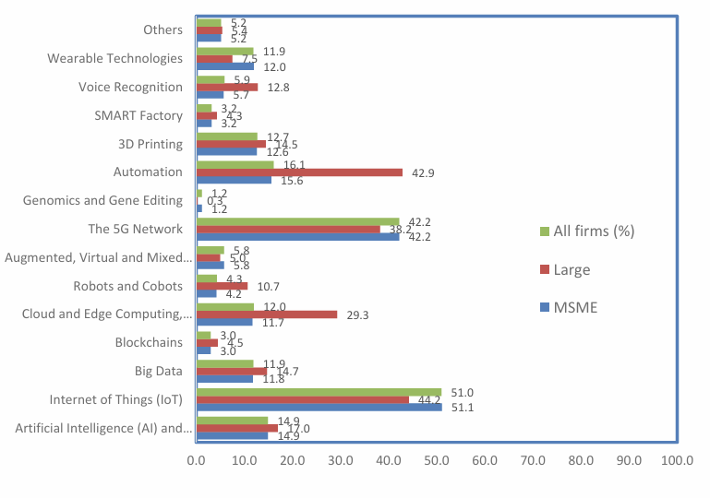

**Figure #. FIRe Technology used by firms by establishment size 2021 PSIA, PIDS**

The most Common FIRe Technology used is Internet of Things (IOT) and 5g network, automation and AI are among the most common FIRe Technology used in agriculture and other manufacturing sectors. However, in terms of firm size, there appears to be no difference in the barriers in using FIRe technologies.

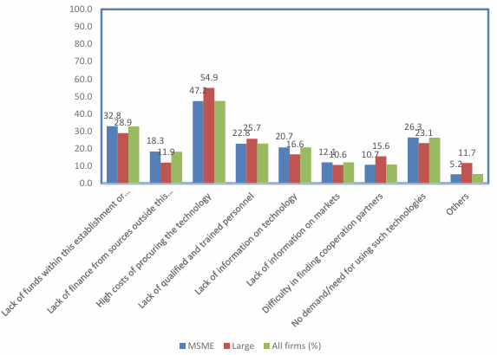

**Figure #. Barriers in FIRe Technology by firm size Source:2021 PSIA, PIDS**

With high costs as the leading barriers in both sectors followed by lack of funding.

### **Synthesis**

The studies and literature above reveal that the adoption of AI and system automation in management inventory and point of sales vastly improve the efficiency of SMEs as well as reveal new opportunities and challenges. Both local and foreign studies shows that the traditional way of managing inventory is inefficient and may cause issues within the business operations, in addition foreign studies shows that the traditional method fails to manage high data complexities which may cause financial strain. The mentioned studies and articles consistently show that AI-driven systems significantly improve efficiency, as adopting AI enhances customer satisfaction, revenue and operational performance, although there are challenges like the limitations of digital infrastructure and awareness in the Philippines most SMEs and businesses are most likely to adopt AI driven systems when given the opportunity. In the global scene the integration of IoT and AI has further boosted foreign businesses’ efficiency showing the advancement of technology that our local SMEs can pursue to have a competitive edge.

# **CHAPTER III METHODOLOGY RESULTS AND DISCUSSIONS**

This chapter will tackle detailed information regarding the methodologies used to develop the ideal system of Metro 7. This chapter will cover the software design products and processes, Requirement analysis, Cost benefit analysis, System architecture, System flow, and System Diagram. Altogether, this section provides detailed approach of methods and procedures towards successful deployment of the project.

## **Software Design, Products and Processes**

**

**Figure #** Iterative Development Cycle

The development of Smart Automation Management System and Data Analytics with AI – Enabled Demand Forecasting for Metro 7 will follow an iterative approach, breaking down the project into manageable cycles. Each iteration builds upon the previous version, refining the system’s features with the feedback to ensure the system works with the needs of the business.

Phase 1: Initial Planning

The researchers and the beneficiary collaborated to identify the core needs:

* Inventory Management System
* Point of Sales
* Reporting and analysis
* Online Orders and advance reservation
* Employee management

Phase 2: Requirements

During this phase the researchers gathered to discuss points and ideas needed for the development of the system. All proponents collected the necessary data and conducted questions and answers to properly analyze the desired plan of the system.

Phase 3: Analysis and Decision Making

The researchers evaluated the feasibility of the solutions for each feature of the system.

Phase 4: Development and Testing

This phase focuses on the development of the system prioritizing features that provide immediate business value. Multiple testing will be on each iteration to identify

Phase 5: Evaluation

This phase is the evaluation of the finished iteration with the beneficiary to assess its efficiency. Within this phase the researchers will be able to gather feedback to improve and refine the system as required. Adjustments for the next iteration will be based on the feedback gathered.

## **Requirement analysis**

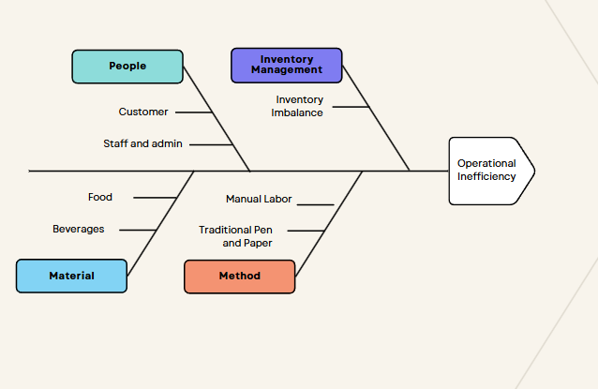

**Figure #.** Ishikawa Diagram

The figure above visualizes possible root cause of revenue loss in Metro 7 Restaurant and bar. Operational inefficiency is heavily tied to loss of revenue. These are the problem areas that the researchers have found when conducting an interview with the identified beneficiary. First is inventory management, Inventory imbalance when restocking leads to loss of revenue when restocking items that are not in demand just stay on the shelf, additionally items like perishables that are not sold on time become spoilt ending in financial losses. Second is the method, within it there are traditional use of pen and paper that may end in data inaccuracies, additionally rigorous manual labor and repetitive tasks end in inefficient operation within the business. Third is the people where untrained staff and admin slow down the process of the business, with slow process comes unsatisfied customer ultimately leading into loss of revenue.

## **Conceptual Design**

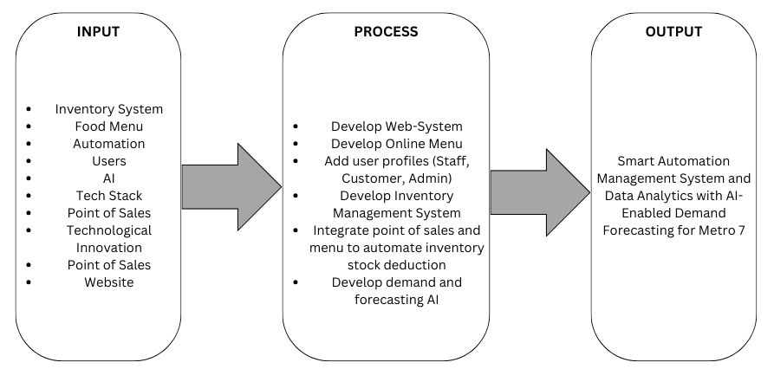**Figure #.** IPO (Input Process Output) Diagram

This section goes over the Metro 7 Resto Bar Software’s core system. The procedure and module of Metro 7 Resto Bar software are discussed in this part. The figure below uses hierarchical organization chart to depict the systems’ module. The figure chart below is used to depict the modules of the system visually. Modules such as online reservation management, advanced online ordering, inventory management, user management, order management, and reporting is designed to work seamlessly together. This modular approach ensures flexibility and scalability, allowing the system to meet the restaurant’s operational needs and enhance customer service experience.

## **Activity Diagram**

This section will show the activity flow of each entity in the web-system.

**Figure #.** Customer Activity Diagram

The figure above shows the activity flow of users, upon accessing the website the users will be able to navigate through the website. However, in order to use the full features and functions of the website a customer must first log-in or register, afterwards they will be able to make an advance order online or make table reservations.

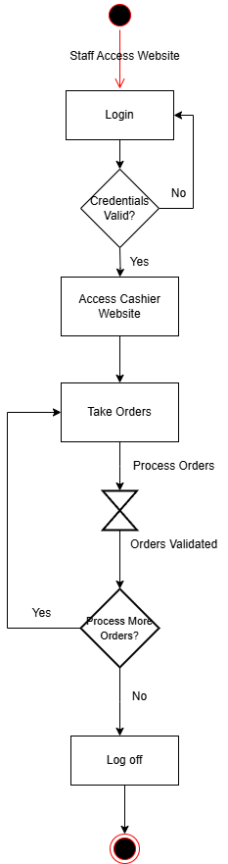

**Figure #.** Staff Activity Diagram

The Figure above shows the activity flow of cashier and service staff, upon logging in the cashier and service staff will be redirected to the appropriate dashboard being able to process orders from walk-in customers and verify payments and orders from online orders.

**Figure #.** Admin Activity Diagram

The figure above shows the activity flow of admins in the Web-System. Upon login the admin will be redirect page to the admin dashboard where the admin will be able to access the inventory management system where they can manage their stocks, access to user profiles where they will be able to oversee and manage profiles of staff and customers, and access to product page to add or delete available products.

## **Block Diagram**

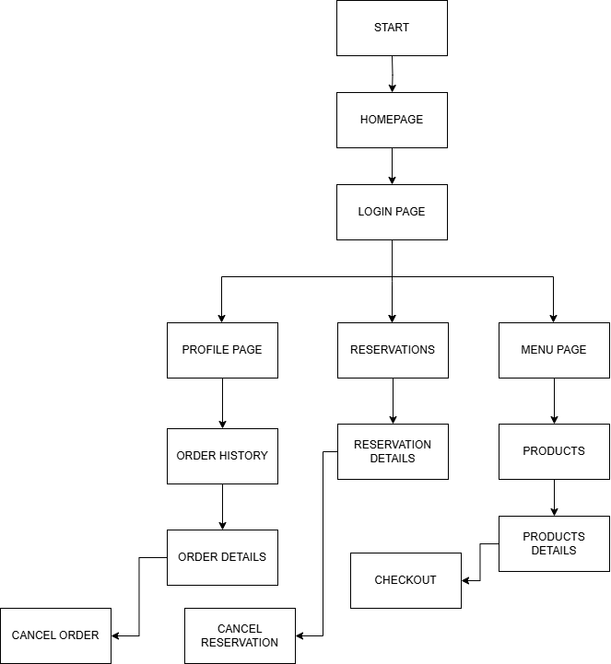

**FIGURE #.** Customer Access Block Diagram

The figure above illustrates the structured organization of customer access within the web-based management system. It shows the levels of customer access and specific features that are available to a registered user. Registered users can view and edit their profile page, giving them a personal space within the web-system. In addition, customers have full access to the online reservation system, allowing them to book a table in advance. Registered users also have full access to an online ordering system, allowing them to browse the product menu, place orders in advance by paying a specific amount based on the sum of the order. This chart is essential for understanding the access of the customer, ensuring that the user can efficiently operate and use every available function of the website system.

**Figure #.** Staff Access Block Diagram

This page is exclusive for Staffs, when user is Authenticated as Staff, they will be routed to Staff site. Users with Staff Authentication will have full access to this page, they will be granted access to several features such as obtaining customers’ orders and details, allowing them to view existing and incoming orders online and locally. They can also view reservation details to cancel reservations and if customers arrive on time, they will mark the reservation as fulfilled. They also have access to Staff’s profile details where they can time in or time out for daily attendance as well as update their profile.

**Figure #.** Admin Access Block Diagram

The Login Admin Hierarchical Chart provides a detailed view of the administrative access structure within the web-based management system. This chart shows the various levels of admin access and their functionalities. Admins have full access to all features, including user and employee management, allowing them to create, update and delete profiles, a product page to add or remove a product from the menu, the inventory page where the full value of the stock will be shown as well as every item in their inventory, the admin also has the ability to create, update and delete items. A view of the orders list where admins can refund or cancel specific orders if need be and a sales page to oversee the sales revenue analysis.

## **System Architecture**

## **Common layers for an information system application**

**Figure #.** Layered Architecture source: [cs.jemu.edu](https://w3.cs.jmu.edu/kirkpams/OpenCSF/Books/csf/html/Architectures.html)

The system architecture shown in the **figure #** shows the process of how the system works. The presentation layer would be the Customer UI where they would be able to interact with the front-end of the system, this layer would allow the Users to interact with the business layer through the Point of Sales system or ordering system of the cashier and service staff. The business Layer may interact with the service layer in this system case would be the admin interface where the admin can check the access levels of each user and also use the business layer. Below the service layer would be the persistence layer, the database where all the data is saved, such as the data for the inventory management system that allows the availability of product for the service and business layers.

## **Entity-Relationship Diagram**

**Figure #.** Entity-Relationship Diagram

The Entity-Relationship Diagram shown in the **figure #** represents the process of how the database works in the system. In this diagram, it will illustrate the entities relating to one another. We have admin, customer, staff, Inventory, products, payments, reservations, tokens, and system and email notifications. Where the key entity is the Inventory that supplies the product’s ingredients. If the product’s ingredients are out of stock from the Inventory the product will be unavailable for orders and can’t be selected by either staff or customers. When the Inventory has a warning or out of stock status the system will then notify the admin to restock the Inventory so the product will be available for orders. Once the order is placed and has been paid an email notification will be sent to the customer who ordered the product. We also have a reservation table that will be filled by the customer and will be verified by the staff and afterwards is saved to the database. Lastly, for authentication purposes, tokens are set for each user including customer, staff and admins for security these tokens are generated every time they login.

## **Cost-Benefit Analysis**

In this section, this will show the costs of the software, hardware and tools that are used during development and the anticipated maintenance costs when the system is deployed. With the help of cost benefits analysis, researchers can determine how much the worth of the project is to ensure the quality will match the costs.

1. Hardware Development Costs

|  |  |  |  |  |
| --- | --- | --- | --- | --- |
| **Recommended Requirements** | **Specifications** | **Quantity** | **Unit Price** | **Costs** |
| Laptop | CYBORG 15 A12U | 1 | 42,000 | Free |
| Laptop | ThinkPad E15 | 1 | 46,000 | Free |
| Laptop | Lenovo IdeaPad Gaming | 1 | 83,000 | Free |
| **Total:** | | | 0 | |

Source: [PC Central PH](https://pccentral.com.ph/) , business.shoppable.ph, smmarkets.ph.

**Table 1. Hardware costs**

The Hardware Development that is used during development is displayed in Table 1. These tools are vital in developing the project although researchers already have it on hand. It is necessary to include this information to determine the recommended specifications for the system to run.

1. Software Development tools costs

|  |  |  |
| --- | --- | --- |
| **Tool** | **Specifications** | **Costs** |
| Front-end tools | React, sass, JavaScript | FREE |
| Back-end tools | Laravel, PHP, JavaScript | FREE |
| Database | MySQL, XAMPP | FREE |
| AI tools | Python, Prophet | FREE |
| **Total:** | | 0 |

**Table 2. Software Development Costs**

The Software Development tools are used during development are displayed in Table 2. This table pertains to the expenses related to utilization of development tools and technologies that are vital for software development, designs and documentation.

1. Utility costs

|  |  |
| --- | --- |
| **Utility** | **Costs** |
| Electricity | 1,000 monthly |
| Internet Connection | 1,500 monthly |
| **Total:** | 2,500 monthly |

**Table 3. Utility Costs**

The Utility Costs that are shown in Table 3 refer to the expenses for the necessities required for the researchers to operate a comfortable and functional working environment.

1. Testing and Deployment costs

|  |  |  |
| --- | --- | --- |
| **Items** | **Specifications** | **Costs** |
| Webhosting | Hostinger.com | 2,081.04 annually |
| Domain name | Hostinger.com | 985.42 annually |
| **Total:** | | 3066.46 annually |

**Table 4. Testing and Deployment Costs**

The Testing and Deployment costs shown in Table 4 refer to the deployment of the system and the anticipated maintenance costs once launched. The Total of 3,066.45 refers to the yearly subscription for the website to be up and running throughout the web. If these total costs to be break down per month it will only cost the proponents 255.55 per month.

1. Summary of Costing

|  |  |
| --- | --- |
| **Items** | **Costs** |
| Hardware Tools | FREE |
| Software Tools | 700 * 6 months |
| Utility Total Costs | 2,500 * 6 months |
| Testing and Deployment Costs | 3,066.46 |
| **Total:** | 22,266.46 for 6 months |

**Table 5. Summary of Costing**

The Summary of Costing shown in Table 5 refers to the total expenses during development. This includes Hardware Tools that are FREE, followed by Software Tools and Utility Total costs that are multiplied by 6 (duration of the development) per month and Testing and Deployment Costs.

## **System Flow**

This section demonstrates the flow of steps in the proposed system, allowing a clear and simple understanding of the interactions within the system.

**Flow Chart**

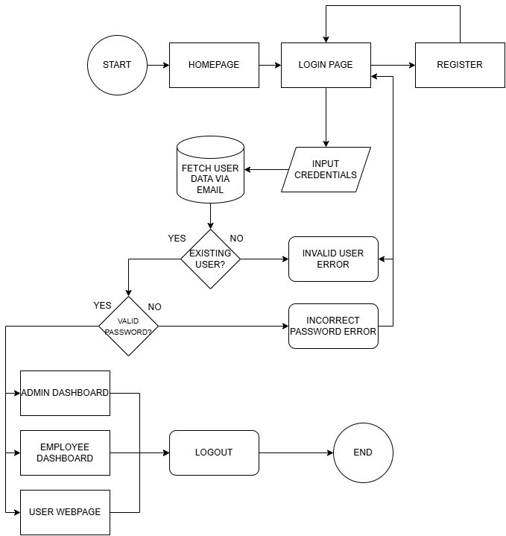

**Figure #**. User Process Flowchart

Upon entering the website, the user will be directed to the home page. From there, the user can navigate to the home, location, menu page, and log in page. The location page shows the contact information and the exact location of branches through maps for easy navigation, the menu page gives the user a view of the available menu items, clicking the log in button redirects the user to the User Login page, where they can log in to their account or create an account using the create account button.

**Figure #** Order Function Flowchart

Users have free access to the Menu page, but to fill up an order a user must first be signed up. Completed orders will be sent straight to the database.

**Figure #** Data Flow Diagram Level 0

The figure above shows the context flow of the system, it compromises Admin who can oversee inventory quantity through a dashboard and can manipulate the inventory quantity which in turn gives an update on the available products. It also contains the Cashier, Service and Customer where they can purchase products by creating an order.

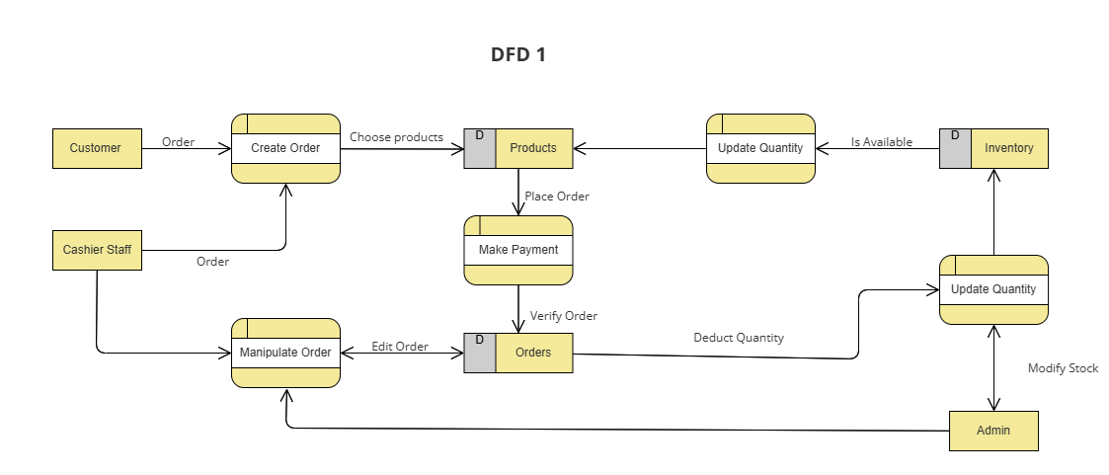 **Figure #** Data Flow Diagram 1

The Level 1 figure above is the expanded version of the level 0 diagram, it starts with the customer and customer staff creating orders and making payments. Afterwards the customer staff can manipulate orders if needed. On the other hand, the admin can also manipulate orders and update the quantity of goods in the inventory which in turn will show the products page if the product is available for the customers to buy.

**Figure #** Data Flow Diagram Level 2

The Figure above shows a much deeper system flow of the website, starting with the log-in of all the present entities, verifying the log in credentials from the database, if the customer is not registered, he/she may register through the register button. For the customers after logging in they will be able to select products to put into their order summary, a payment method will be given which the Cashier staff will verify, if it is verified the order will proceed to be shown as paid, if unverified the order will not take place. Both the cashier and service staff could accept and change orders, cashier staff for online advance payment and walk in customers and service staff for walk in customers when needed. The cook staff will have access restrictions only by being able to view the orders page. The staff will not be able to register their own account, an admin must be present so the admin can register an account for the staff. The admin will have access to all functions and additional functions of manipulating the inventory quantity stocks, removing an item and the ability to add or remove a product on the product page.

**Use-Case Diagram**

This segment will visualize the user’s interaction with the system and shows the important relationship between the user and different entities in which the user is involved.

**Figure #** Use Case Diagram

The Figure Above shows that for the business it needs to have a good inventory system. It caters to both Online and walk in orders by giving the menu an update on what product is available based on the current stocks. The customer has access to the website where he can check the store information and make online purchases. The walk-in customer can order through the cashier. The cashier will have access to the cashier dashboard by logging in to the website with a staff account and will be able to process and manipulate orders. The service will be able to take additional orders from current customers to add to their orders. The cook will have a view of the order lists to see which order needs to be done. The admin will have access to the admin dashboard giving the admin the ability to manipulate the inventory stocks, the admin will also oversee profiles and accounts which the admin can create an account for staff, delete accounts and update accounts.

## **Forecast and Demand Method**

The AI tool that will be used for this Web-System will be Facebook Prophet. Prophet is an open source, time-series forecasting tool developed by Facebook to identify trends and seasonality. It is designed to forecast time-series data which are data collected over a period of time allowing a much better understanding of trends and patterns. This particular AI model uses and additive model, allowing it to decompose time series data into three components, these components being trend, seasonality and holiday effects. With this particular model businesses will be able to efficiently predict demand and make informed decisions based on consolidated data.

## **Development and Testing**

The development of this Web-System will use the following Tech Stack: SASS, PHP, REACTJS, LARAVEL, SQL. The developers will use ReactJS to create the function and components of the front end of the Web-System along with SASS (Syntactically Awesome Style Sheet) to design the Web-Page. PHP will be used to create the back-end functions additionally using Laravel for its framework. The developers will be utilizing SQL in the first chapter of the capstone.

In the testing phase utilizing the iterative development lifecycle the developers will be able to test each and every function developed before and after implementation to gauge the performance and efficiency of the code. Gathering feedback from the beneficiary and its possible users the developers will be able to improve the system accordingly.

## **Implementation Plan**

The researchers will start the implementation plan for the Smart Automation Management System and Data Analytics with AI-Enabled Demand Forecasting for Metro 7 with the planning phase to gather requirements and information needed for the project and define its scope. Next, the designing phase creation of system architecture and user interface prototype. Once the designing phase is completed, researchers will begin the development phase, involves working with the actual project setting up its environment, core modules and AI for demand forecasting that is also compatible with mobile interface. Researchers will also ensure tight and safe security for users’ information and will be conducting a code review and testing to ensure a bug safe system. After the development phase, researchers will start the documentation phase to create documentation of user’s manual, conduct a training session for staff and admins, and gather feedback prior 2 weeks before deployment of the system. Using the gathered feedback, we will use the remaining days before deployment to enhance the system.

Lastly, once the system is deployed researchers will provide onsite support for monitoring system performance, technical support and collecting user feedback for improvements. This Implementation plan will ensure the accuracy, efficiency and effectiveness of the system and deliver it on time.

# References

|  |  |
| --- | --- |
| [1] | V. Kropov, "How to benefit from AI demand forecasting," May 2024. [Online]. Available: https://www.n-ix.com/ai-demand-forecasting/. |
| [2] | R. Gbadebo, "The Impact of Artificial Intelligence on Inventory Management in Manufacturing Industries," December 2023. [Online]. Available: https://www.researchgate.net/publication/376481875_The_Impact_of_Artificial_Intelligence_on_Inventory_Management_in_Manufacturing_Industries. |
| [3] | Smith, A., Doe,R, "Advanced data-driven models for demand forecasting in dynamic retail environments.," 2022. [Online]. Available: https://doi.org/10.1007/s41060-021-00262-y. |
| [4] | Lee, K., Kim, S., " Improving demand forecasting in e-commerce through hybrid machine learning models," *International Journal of Forecasting,* pp. 1205-1217, 2021. |
| [5] | A. R. Jakkula, "Predictive Analytics in E-Commerce: Maximizing Business Outcomes," June 2023. [Online]. Available: https://www.researchgate.net/publication/381777712_Predictive_Analytics_in_E-Commerce_Maximizing_Business_Outcomes. |
| [6] | T. Maghirang, "State of AI in the Philippines in 2025: A range of perspectives," 9 February 2025. [Online]. Available: https://www.pids.gov.ph/details/news/in-the-news/state-of-ai-in-the-philippines-in-2025-a-range-of-perspectives. |
| [7] | Manila Bulletin, "Digital divide, lack of awareness hinder AI integration in Philippine businesses," 31 December 2024. [Online]. Available: https://mb.com.ph/2024/12/31/ph-businesses-lagging-in-ai-adoption#google_vignette. |
| [8] | Yondu, "The State of Artificial Intelligence in the Philippines," 4 September 2024. [Online]. Available: https://www.yondu.com/articles/the-state-of-artificial-intelligence-in-the-philippines. |
| [9] | TrueLogic, "AI Adoption in the Philippines," 11 June 2024. [Online]. Available: https://www.truelogic.com.ph/blog/truelogic-episode-105-recap-adoption-of-ai-in-the-philippines/. |
| [10] | A. J. I. L. Fulgar, "Artificial intelligence on the built industries in the Philippines," 9 June 2024. [Online]. Available: https://business.inquirer.net/404736/artificial-intelligence-on-the-built-industries-in-the-philippines. |
| [11] | Erfan Babaee Tirkolaee, "Application of Machine Learning in Supply Chain Management: A Comprehensive Overview of the Main Areas," 22 June 2021. [Online]. Available: https://onlinelibrary.wiley.com/doi/full/10.1155/2021/1476043. |
| [12] | J. Ugbebor and M. Adeteye, "Automated Inventory Management Systems with IoT Integration to Optimize Stock Levels and Reduce Carrying Costs for SMEs: A Comprehensive Review," 2024. [Online]. Available: https://newjaigs.com/index.php/JAIGS/article/view/257. |
| [13] | T. Falatouri, F. Darbanian, P. Brandtner and C. Udokwu, " Predictive Analytics for Demand Forecasting—A Comparison of SARIMA and LSTM in Retail SCM," 2022. [Online]. Available: https://doi.org/10.1016/j.procs.2022.01.298. |
| [14] | B. Khumar Jha and S. Pande, "Time Series Forecasting Model for Supermarket Sales using FB-Prophet," April 2021. [Online]. Available: https://www.sci-hub.st/downloads/2021-06-06/f1/kumarjha2021.pdf. |
| [15] | A. Arnaiz, "Optimizing inventory management and demand forecasting system using time series," November 2023. [Online]. Available: https://wjarr.co.in/wjarr-2023-2456. |
| [16] | M. G. C. Galang, C. K. I. Miranda, C. R. Quisto, M. E. B. Reyes and A. B. Roca, "The Effect of Artificial Intelligence Adoption on," February 2025. [Online]. Available: https://papers.ssrn.com/sol3/papers.cfm?abstract_id=5057298. |
| [17] | F. M. A. Quimba, N. I. S. Moreno and A. M. C. Salazar, " Readiness for AI adoption of Philippine business and industry: The government's role in fostering innovation," December 2024. [Online]. Available: https://www.econstor.eu/bitstream/10419/311724/1/1917117426.pdf. |
| [18] | C. Cabungcal, C. Enriques, Z. Medios, H. Ruiz, J. L. Villanueva, B. Gacrama and M. Gaoat, " Impact of Inventory Management on Financial Performance of MSMEs in Santiago City," 2023. [Online]. Available: https://pdfs.semanticscholar.org/3e9f/8dbea8d2ce229175c78b0bed7fb5526413b0.pdf. |
| [19] | J. R. G. e. a. Albert, ": The Extent of Innovation in Philippine Business and Industry: Results of the 2021 PIDS Survey of Innovation Activities, PIDS Discussion Paper Series, No. 2023-11, Philippine Institute for Development Studies (PIDS), Quezon City," 2023. [Online]. Available: https://www.econstor.eu/bitstream/10419/284610/1/pidsdps2311.pdf. |
| [20] | S. J. C. Español, R. Fronda, M. R. C. Villarica and G. L. Intal, " SHOP BUDDY Enhanced Automated Chatbot for Any E-commerce Website with Data Analytics Functionalities," 5 April 2021. [Online]. Available: https://www.ieomsociety.org/brazil2020/papers/778.pdf. |